# **Process Report**

Project Start

The entire ProCp Project was required to make a simulation app for a company named “SIM Software”. They want us to create a city planner which can configure the roads and crossings in a city to simulate traffic and pedestrian flow during rush hour. The simulation should be able to provide the means to optimize the configuration of roads, crossings and traffic lights via statistics related to how the traffic resolves.

Iteration 1:

The First Week it was unclear what we could do. Although we had the idea to make the app, we didn’t know what way we could approach together to make the app. After having a few discussion we came up with an idea which was to create a concrete project plan that everyone will follow. We made the use case diagram to make understand each other about the user interaction with the app.

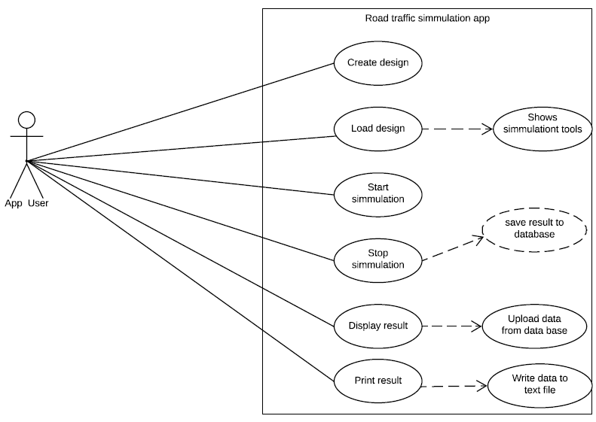

After having an idea of how the app should work we started making the use case description. Our main goal at that time was to make the documents easy to understand for everyone. Up until week 5 we made the design document and we finished our URS. We were having pretty solid goal to move on.

Iteration 2

In week 8, we had our very first presentation in front of our client Mr. Basjan. He was quite satisfied with our presentation. However, he suggested us to add a value to our app so that it interests him. After having the suggestion we sat down with our tutor and got the suggestion on how to expand our app. It came as a surprise to us that we couldn’t have a solid understanding this time with our group members towards our approach. Meanwhile I(Fahim) was googling on how to make a traffic simulation app and found some quite interesting ideas with some codes as well. We thought it would be better if we could share what we found so that everyone gets an idea. After sharing the idea everyone was happy and they also got good learning stuffs except one of our team members. He was not satisfied as he was thinking to extend the app using waypoints. We were finding it hard to agree with him as he couldn’t show us how to work with waypoints. So, after that 4 of us started working on our own and made progress towards building our app and documentation. We made the drag and drop function work and also we were able to create cars and make it run in the city. Our tutor was worried about our documentation as it wasn’t on the git so we put the documents on git.

Iteration 3

This block is the time when we were about to wrap up with our progress. After such a long period of hard work we were moving towards finishing our end goal. Suddenly our project leader came up with his waypoint idea again and modified our codes that we have written so far. Then we gave him the time to show us his code and hook up those codes to our interface. Surprisingly, he was successful to show a working app with waypoints. We then moved on to unit testing and make design document more better. And now, We have a working app that simulates the traffic and we were trying to create a value so that our client can be convinced to buy our product. So, we thought of having data collection in our app. In other words, the app would be able to produce some data to provide the client with more clear idea of what is going on in city planner such as how many cars are in a crossing, how long does it take for a car to wait till the light is green.

Remarks

First of all, we are all happy that our team was successful to create such a good app that simulates the traffic. Although we had a slow start and less clear vision of our goal, we were able to manage everything at the eleventh hour. It would be more better if during iteration 2 we would still work together with our project leader. As we are students trying to learn how to work in a team we believe that we have understood well how to work in a team. We learned from internet and most importantly we learned from the mistakes that we made. And that’s what made us good team players.